7.13.4 Invoice Post
Via this function we manually post already existing invoice processed in 7.13.3.
Invoice – To: invoice number
GL Effetive Date: means date of issue which will be displayed on the invoice
GL Consolidated or Detail: enter detail
Print Lot/Serial Numbers Shipped: must be clicked
Output: rolo
+ Next
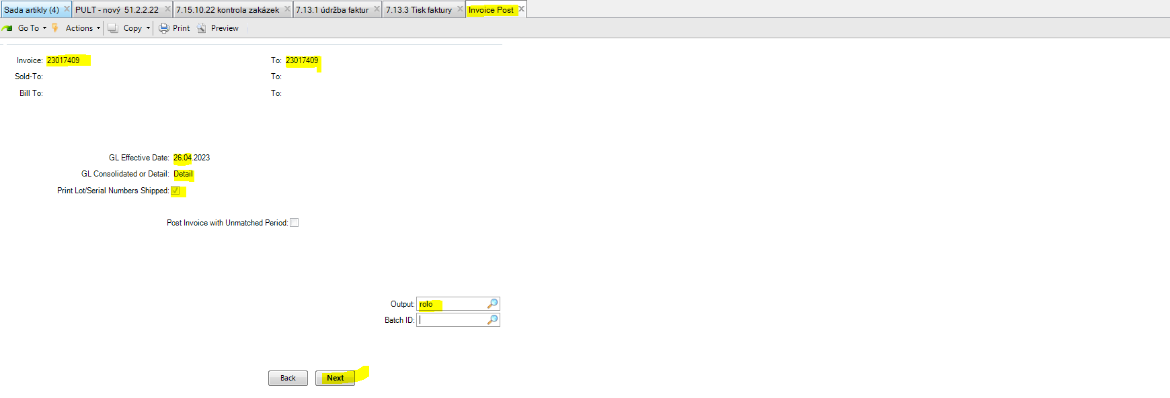
Then the invoice is posted and QAD shows you below report. Only posted invoice can be accepted into your domain upon reciept the goods. Also when creating a claim in QAD the invoice has to be posted.
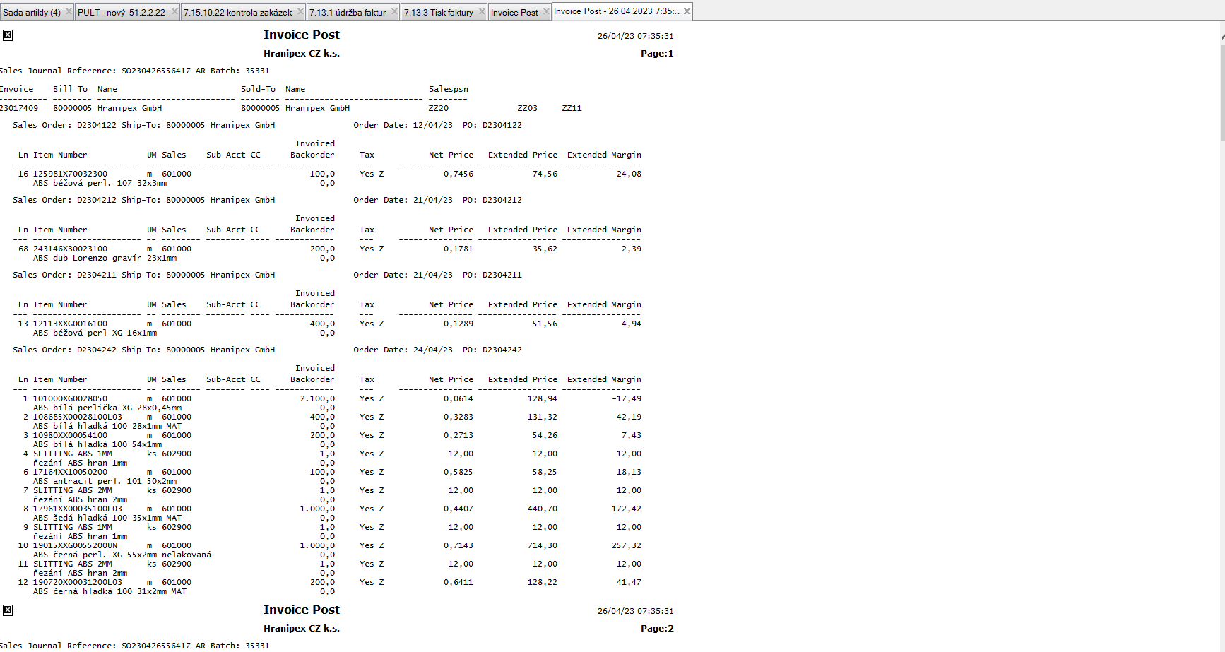Be very carefull with the posting, what you type and press … After the invoice is posted, there is no way back. No storno is possible. The correction document is only a credit note. If possible, it is better to wait untill QAD post the invoice automatically by regular batch.

